Implementing a Serverless Architecture for the Café

10.3HD

**Task 1: Downloading the Source Code**

* **Objective**: Download and inspect two .zip files:
  + salesAnalysisReportDataExtractor.zip: Extracts sales data from the RDS database.
  + salesAnalysisReport.zip: Formats and sends the daily report via email.
* **Purpose**: Understand what each Lambda function is responsible for before deploying them.
* 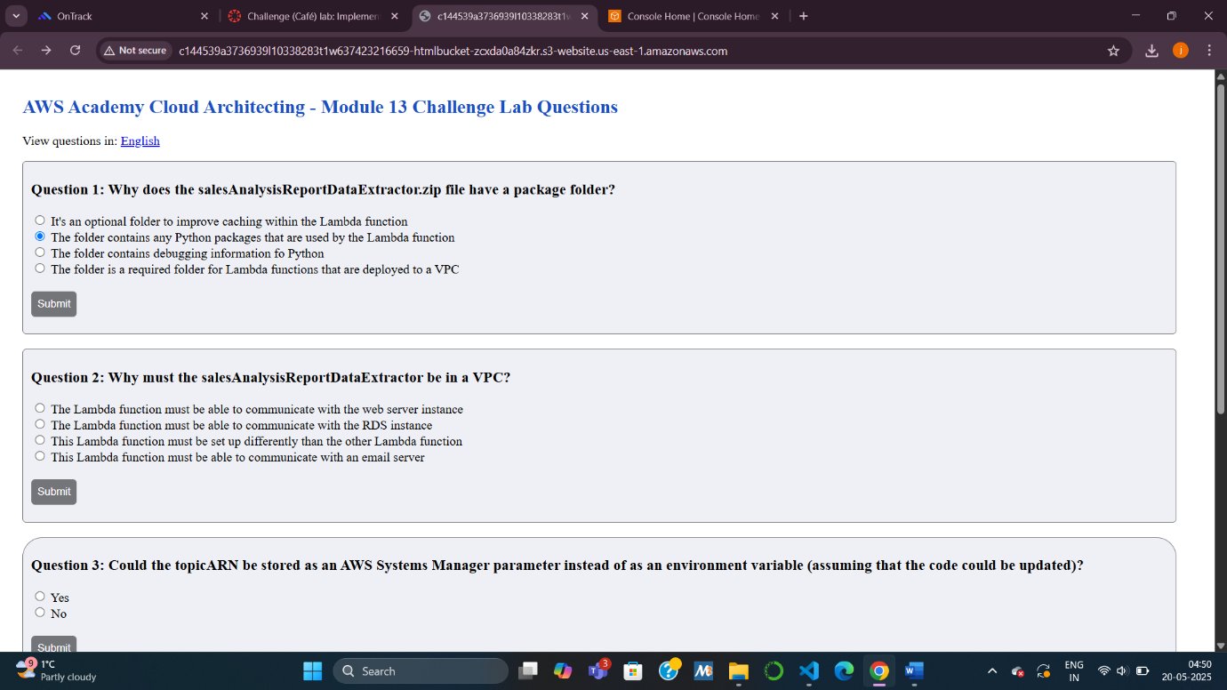
* A screenshot of a computer

  AI-generated content may be incorrect.
* A screenshot of a computer

  AI-generated content may be incorrect.

**Task 2: Creating the DataExtractor Lambda Function in the VPC**

* **Step 1**: **Create a new security group** (LambdaSG)
  + Outbound rules: Allow all traffic.
  + VPC: Use the provided Lab VPC.
* **Step 2**: **Update the existing DatabaseSG security group**
  + Add an inbound rule: type MYSQL/Aurora and source as the LambdaSG security group.
  + Purpose: Allow Lambda to access the RDS database.
* **Step 3**: **Create the Lambda function salesAnalysisReportDataExtractor**
  + Runtime: Python 3.11
  + Role: salesAnalysisReportDERole
  + VPC Configuration: Use both Private Subnet 1 and 2 + LambdaSG.
  + Upload code zip, set handler to salesAnalysisReportDataExtractor.lambda_handler
  + Timeout: 30 seconds, Memory: 128 MB
  + **Purpose**: Extract sales data securely inside the VPC from RDS.

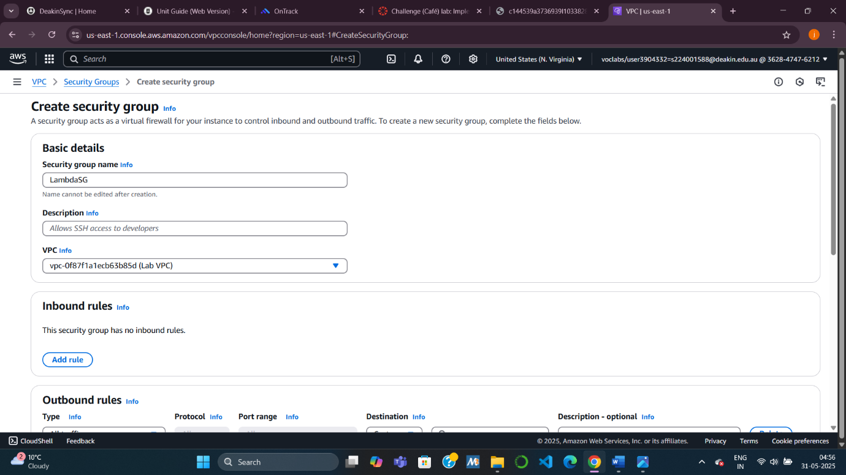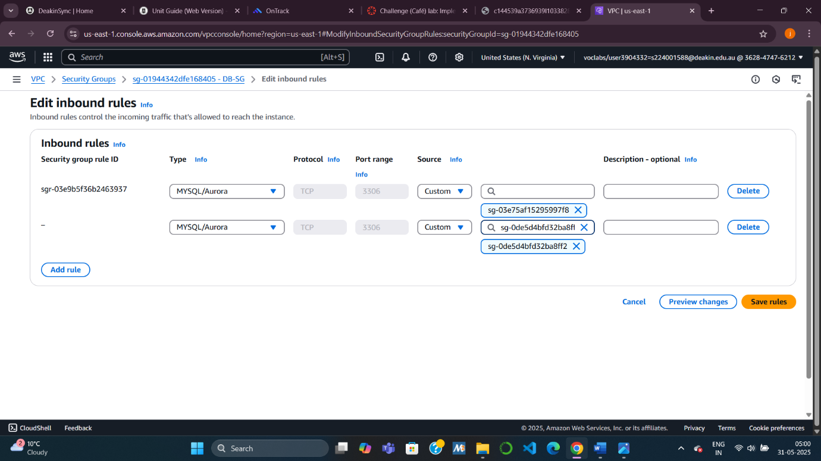

**Task 3: Creating the SalesAnalysisReport Lambda Function**

* **Create Lambda function salesAnalysisReport**
  + Role: salesAnalysisReportRole
  + Upload the second zip file.
  + Set handler: salesAnalysisReport.lambda_handler
  + Same timeout (30s) and memory (128 MB) settings.
  + **Purpose**: Generate report content and send it via SNS.

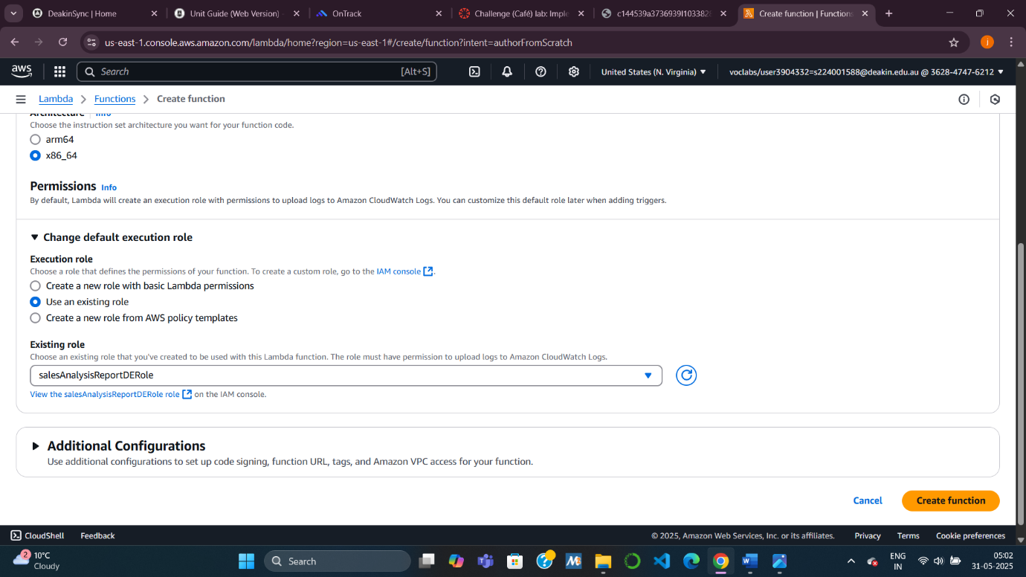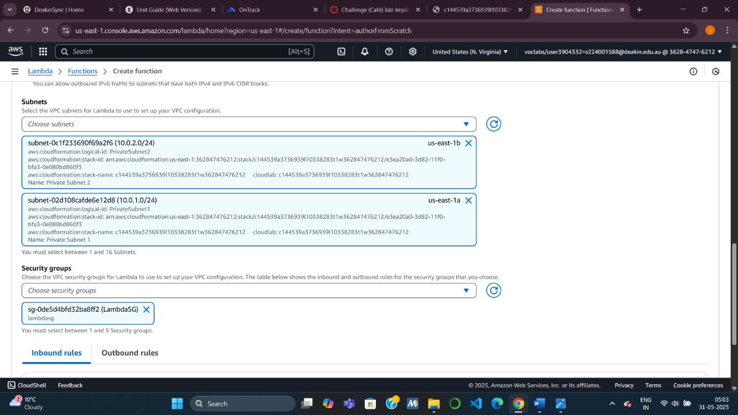

**Task 4: Creating an SNS Topic**

* **Step 1**: Create an SNS topic
  + Name: SalesReportTopic, Display Name: “Sales Report Topic”
* **Step 2**: Add environment variable to Lambda
  + Key: topicARN
  + Value: The ARN of the topic just created
  + **Purpose**: Let the Lambda function know where to send the report.

**Task 5: Creating an Email Subscription to the SNS Topic**

* **Step 1**: Subscribe your email to the SNS topic.
* **Step 2**: Confirm the subscription from your inbox (check spam folder).
* **Purpose**: Enable email delivery of the sales report.

**Task 7: Setting up Amazon EventBridge to Trigger Daily**

* **Step 1**: Create a scheduled EventBridge rule (cron or rate expression)
  + Example: cron(0 14 * * ? *) to run at 2:00 PM UTC
* **Step 2**: Attach the salesAnalysisReport Lambda function to the rule.
* **Step 3**: Use the existing IAM role: mySchedulerRole
* **Purpose**: Automate daily execution of the report at a fixed time.

